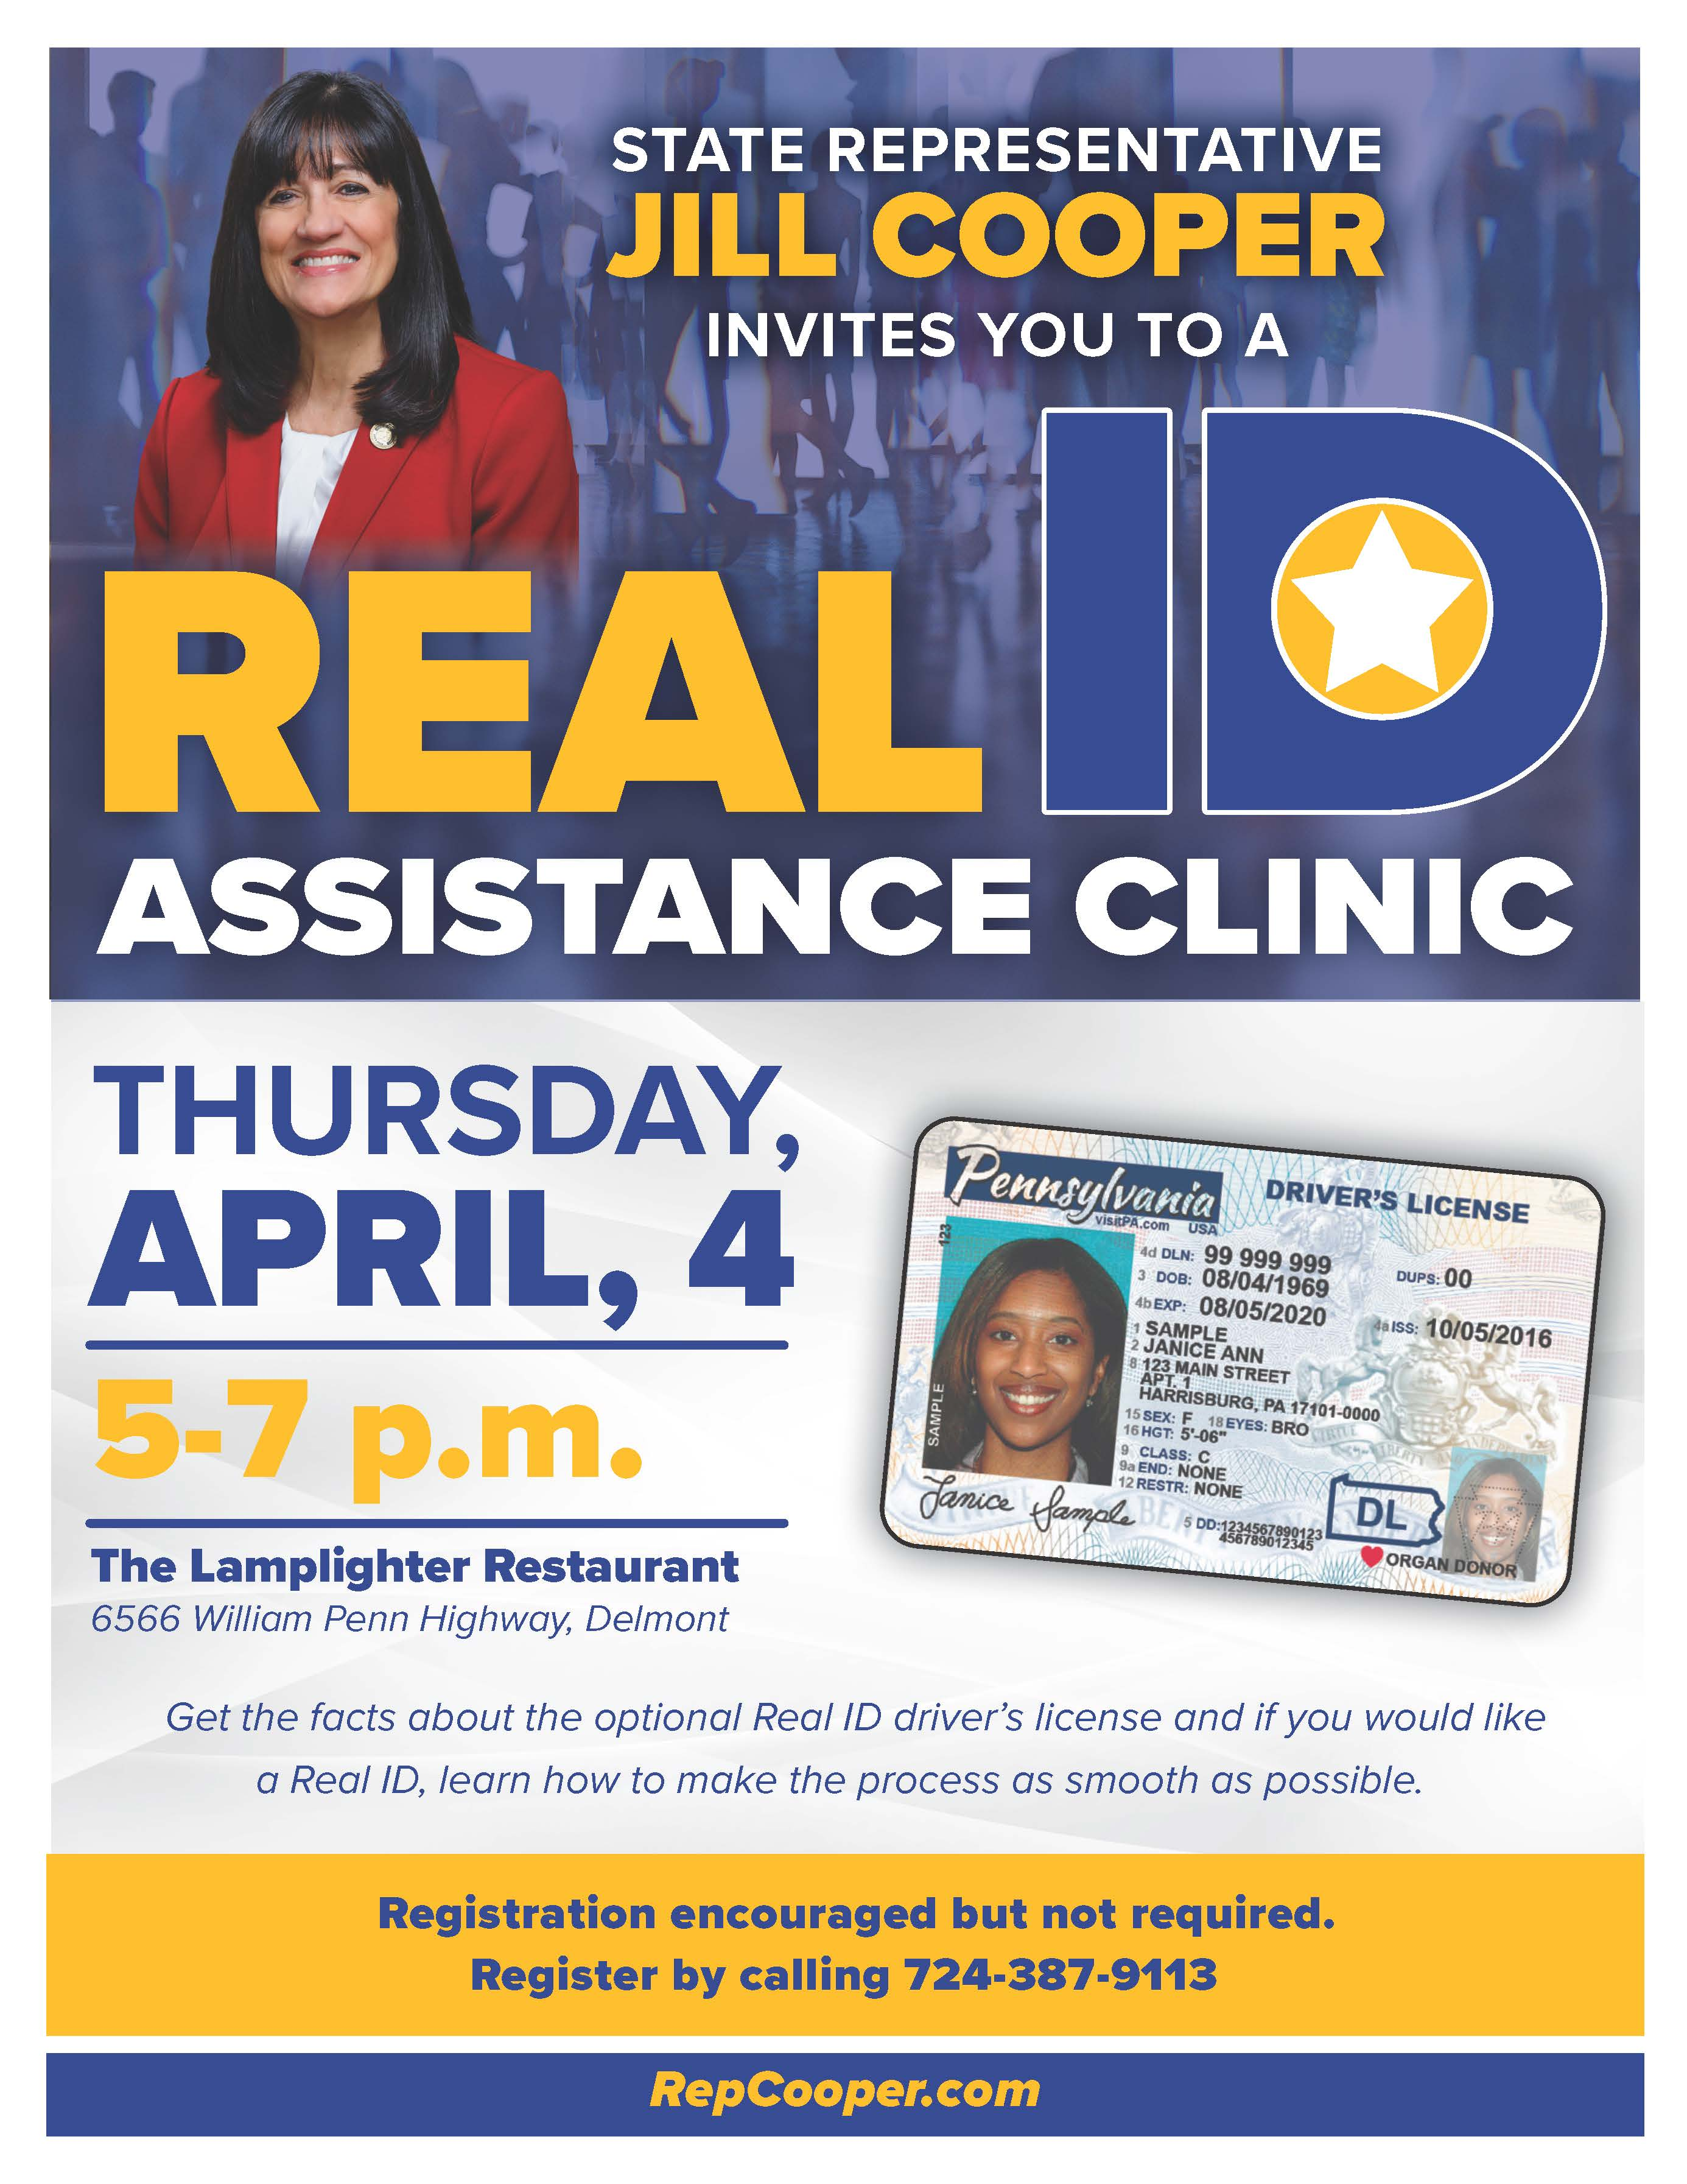
If you have questions about Real ID, join me for this special event Thursday, April 4, from 5-7 p.m. at the Lamplighter Restaurant in Delmont. Registration is encouraged but not required. Call us at 724-387-9113 to register or if you have any questions.

